- Install the lastest version of VirtualBox (https://www.virtualbox.org/wiki/Downloads)

- Install Hortonworks Sandbox VM (http://hortonworks.com/hdp/downloads/)
- Remember to create Shared folder in Settings with auto-mount attribute.
(This step's already finished in Part 1)

- Install JDK (http://www.oracle.com/technetwork/java/javase/downloads/index.html) and Eclipse (https://eclipse.org/downloads/)
Because Hortonworks has the Apache Spark inside so we do not need to install Apache Spark.

- Open Elipse and create a new Java project. It's name is ApacheSpark

- Right click project -> Configuration -> Convert to Maven project -> OK

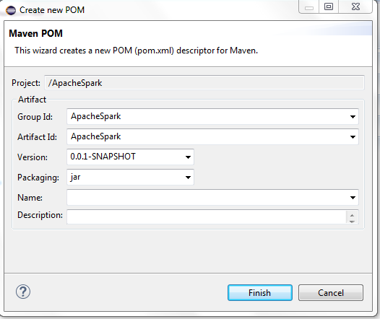

- Open pom.xml and add the following values:
<dependencies>
<dependency>
<groupId>org.apache.spark</groupId>
<artifactId>spark-core_2.10</artifactId>
<version>1.2.0</version>
</dependency>
</dependencies>

- Create Tools class and add these code in this class

import java.util.ArrayList;
import java.util.List;

import scala.Tuple2;

public class Tools {
public static String[] getNeighbor(String[] words, int index) {

List<String> neighbor = new ArrayList<String>();

for (int i = index + 1; i < words.length; i++) {
if (!words[index].equals(words[i])) {
neighbor.add(words[i]);
} else
break;
}

return neighbor.toArray(new String[neighbor.size()]);

}

public static Tuple2<String, Integer> myFindTupleIn(List<Tuple2<String, Integer>> source, String input){
for (Tuple2<String, Integer> tuple2 : source) {
if(tuple2._1.equals(input))
return tuple2;
}
return null;
}
}

- Create SparkExample class and add these code in this class

import org.apache.spark.SparkConf;
import org.apache.spark.api.java.JavaPairRDD;
import org.apache.spark.api.java.JavaRDD;
import org.apache.spark.api.java.JavaSparkContext;
import org.apache.spark.api.java.function.FlatMapFunction;
import org.apache.spark.api.java.function.Function2;
import org.apache.spark.api.java.function.PairFunction;
import common.Tools;
import scala.Tuple2;

import java.util.ArrayList;
import java.util.Comparator;
import java.util.List;

public class SparkExample{
private static final FlatMapFunction<String, Tuple2<String, String>> WORDS_EXTRACTOR = new FlatMapFunction<String, Tuple2<String, String>>() {
@Override
public Iterable<Tuple2<String, String>> call(String s) throws Exception {
ArrayList<Tuple2<String, String>> result = new ArrayList<Tuple2<String, String>>();
String[] words = s.toString().split(" ");
for (int i = 0; i < words.length; i++) {
String[] neighbors = Tools.getNeighbor(words, i);
for (int j = 0; j < neighbors.length; j++) {
result.add(new Tuple2<String, String>(words[i],
neighbors[j]));
}
}
return result;
}
};

private static final PairFunction<Tuple2<String, String>, Tuple2<String, String>, Integer> WORDS_MAPPER = new PairFunction<Tuple2<String, String>, Tuple2<String, String>, Integer>() {
@Override
public Tuple2<Tuple2<String, String>, Integer> call(
Tuple2<String, String> s) throws Exception {
return new Tuple2<Tuple2<String, String>, Integer>(s, 1);
}
};

private static final PairFunction<Tuple2<String, String>, String, Integer> COUNT_MAPPER = new PairFunction<Tuple2<String,String>, String, Integer>() {

@Override
public Tuple2<String, Integer> call(Tuple2<String, String> t)
throws Exception {
return new Tuple2<String, Integer>(t._1, 1);
}
};

private static final Function2<Integer, Integer, Integer> WORDS_REDUCER = new Function2<Integer, Integer, Integer>() {
@Override
public Integer call(Integer a, Integer b) throws Exception {
return a + b;
}
};
private static final Comparator<Tuple2<Tuple2<String, String>, Double>> compareTuple = new Comparator<Tuple2<Tuple2<String, String>, Double>>() {

@Override
public int compare(Tuple2<Tuple2<String, String>, Double> arg0,
Tuple2<Tuple2<String, String>, Double> arg1) {
if (arg0._1._1.equals(arg1._1._1)) {
return arg0._1._2.compareTo(arg1._1._2);
} else {
return arg0._1._1.compareTo(arg1._1._1);
}
}
};

public static void main(String[] args) {
if (args.length < 1) {
System.err.println("Please provide the input file full path as argument");
System.exit(0);
}

SparkConf conf = new SparkConf().setAppName("sparkexample.SparkExample").setMaster("local");
JavaSparkContext context = new JavaSparkContext(conf);

JavaRDD<String> file = context.textFile(args[0]);
JavaRDD<Tuple2<String, String>> words = file.flatMap(WORDS_EXTRACTOR);
JavaPairRDD<Tuple2<String, String>, Integer> pairs = words.mapToPair(WORDS_MAPPER);
JavaPairRDD<String, Integer> pairsCount = words.mapToPair(COUNT_MAPPER);
List<Tuple2<Tuple2<String, String>, Integer>> counter = pairs.reduceByKey(WORDS_REDUCER).collect();
List<Tuple2<Tuple2<String, String>, Double>> finalResult = new ArrayList<Tuple2<Tuple2<String,String>,Double>>();
List<Tuple2<String, Integer>> counterCount = pairsCount.reduceByKey(WORDS_REDUCER).collect();
counter.forEach(f -> {
Tuple2<String, Integer> tuple = Tools.myFindTupleIn(counterCount, f._1._1);
finalResult.add(new Tuple2<Tuple2<String,String>, Double>(f._1, (double)f._2 / tuple._2));
});
finalResult.sort(compareTuple);
JavaPairRDD<Tuple2<String, String>, Double> finalFile = context.parallelizePairs(finalResult);
finalFile.saveAsTextFile(args[1]);
}
}

- Rigt click to project -> Run As -> Run Configuration:

- Create Maven Build profile, its name is ApacheSpartMaven
- Set goals: "clean install"
- Click Run

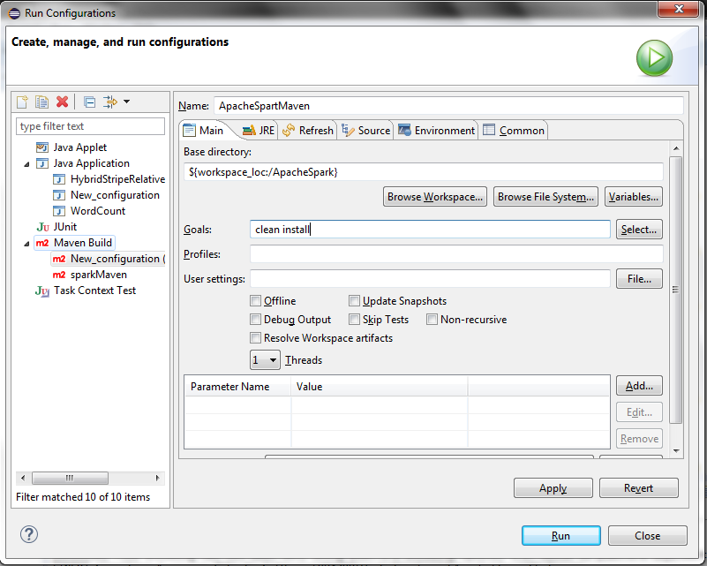

When we click Run button, if you get build error (No compiler is provided in this environment.) no complier was specified. Please following these bellowing instructions to fix it:
- Go to pom.xml
- Add the following value:
<plugins>
<plugin>
<artifactId>maven-compiler-plugin</artifactId>
<version>3.1</version>
<configuration>
<source>1.6</source>
<target>1.6</target>
<fork>true</fork>
<executable>{PATH TO YOUR JDK}\bin\javac.exe</executable>
</configuration>
</plugin>
</plugins>

Now the pom.xml is:

<project xmlns="http://maven.apache.org/POM/4.0.0" xmlns:xsi="http://www.w3.org/2001/XMLSchema-instance" xsi:schemaLocation="http://maven.apache.org/POM/4.0.0 http://maven.apache.org/xsd/maven-4.0.0.xsd">
<modelVersion>4.0.0</modelVersion>
<groupId>sparkApache</groupId>
<artifactId>sparkApache</artifactId>
<version>0.0.1-SNAPSHOT</version>
<build>
<sourceDirectory>src</sourceDirectory>
<plugins>
<plugin>
<artifactId>maven-compiler-plugin</artifactId>
<version>3.1</version>
<configuration>
<source>1.6</source>
<target>1.6</target>
<fork>true</fork>
<executable>C:\Program Files\Java\jdk1.8.0_40\bin\javac.exe</executable>
</configuration>
</plugin>
</plugins>
</build>
<dependencies>
<dependency>
<groupId>org.apache.spark</groupId>
<artifactId>spark-core_2.10</artifactId>
<version>1.2.0</version>
</dependency>
</dependencies>
</project>

- After that, we rebuild maven project will generate a JAR file(ApacheSpark-0.0.1-SNAPSHOT.jar) in {YOUR PROJECT FOLDER}/target.

- Create a input file (text.csv) in /user/hue/spartInput folder
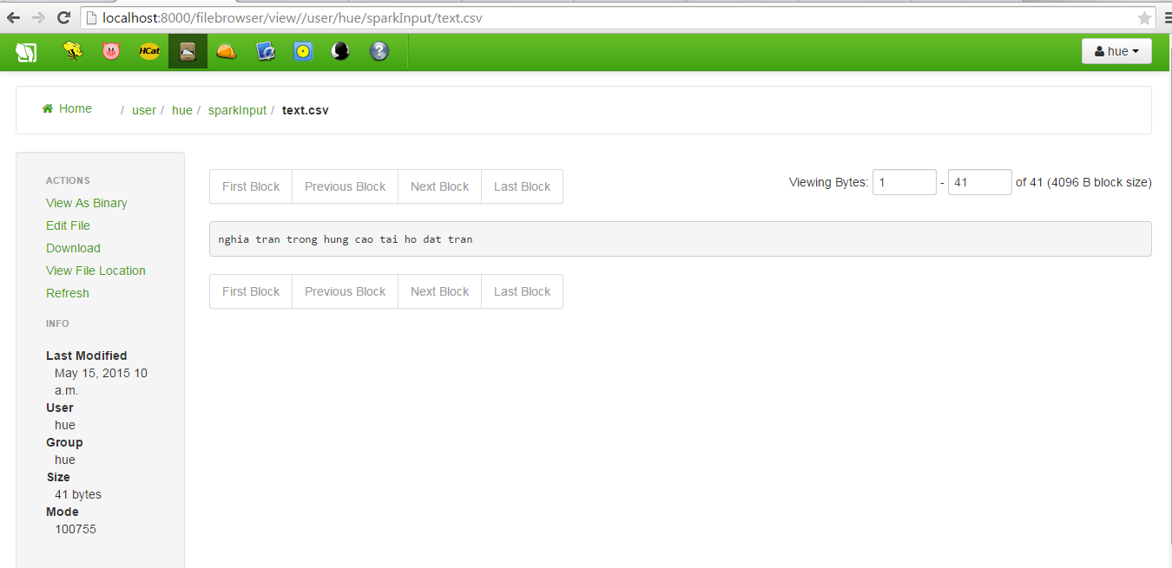

- Copy JAR file (ApacheSpark-0.0.1-SNAPSHOT.jar) into shared folder of VirtualBox (C:\Shared folder)

Go to SSH of virtualbox and type cd /usr/bin

Type the follow command
spark-submit --class SparkExample --master local[2] /media/sf_shared_folder/ApacheSpark-0.0.1-SNAPSHOT.jar /user/hue/spartInput/text.csv /user/hue/ouputspark

--class SparkExample is the main Java class with the public static void main method
--master local[2]" starts the cluster locally using 2 CPU cores
/media/sf_Shared /ApacheSpark-0.0.1-SNAPSHOT.jar is the path to your jar maven project file
/user/hue/sparkInput is a demo local file which contains some words
/user/hue/ouputspark is the directory where the results should be saved

- . After executing successfully, go to output folder (/user/hue/ouputspark) in order to check the result.

